Report on Formula-1 Race Championship - 2023

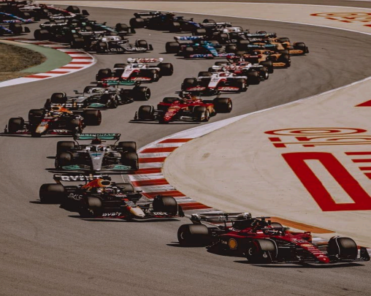

***Submitted by: Garima Singh***

***Roll No: 2230119***

***Course: BSc Hons in Physics***

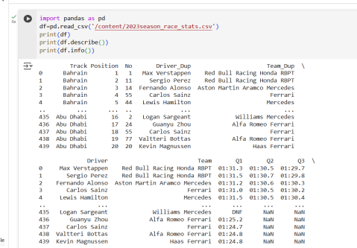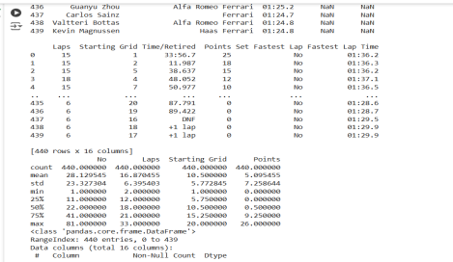

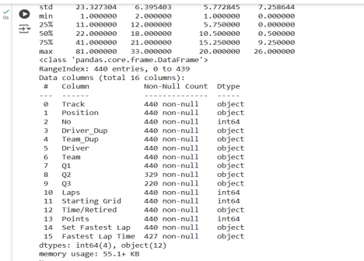

*The* ***Formula 1 2023 season*** *was an exhilarating year of high-speed racing featuring world-class drivers and iconic teams competing across multiple circuits worldwide. The season consisted of several Grands Prix held at different tracks, each offering unique challenges in terms of layout, weather, and race strategy.*

***Key Components of the Season:***

*1.* ***Drivers and Teams:*** *Formula 1 has 10 teams, each with two drivers, making a total of 20 drivers competing in the championship. Teams like Red Bull, Mercedes, Ferrari, and McLaren play a pivotal role in the season.*

*2.* ***Race Weekends:*** *Each Grand Prix typically follows a format including practice sessions, qualifying sessions (Q1, Q2, and Q3), and the final race.*

*3.* ***Points System:*** *Points are awarded based on finishing positions, with additional points for the fastest lap if the driver finishes in the top 10. The winner gets 25 points, second place earns 18 points, and so on down to 1 point for 10th place.*

*This dataset has 440 rows and 16 columns. The statistical analysis for each column( max,min,count etc.) is displayed.*

***Explanation of Dataset Columns/Features:***

***1. Track***

*The name of the circuit where the race took place (e.g., Silverstone, Monza, Circuit de Monaco).*

***2. Position***

*The final finishing position of the driver in the race.*

***3. Driver***

*The name of the driver participating in the race (e.g., Max Verstappen, Lewis Hamilton).*

***4. Team***

*The team or constructor for which the driver races (e.g., Red Bull Racing, Mercedes-AMG Petronas).*

***5. Q1, Q2, Q3***

*Lap times set by the driver in each qualifying session.*

*Values:*

*● Time (in minutes and seconds): The best time achieved by the driver in that session.*

*● DNF (Did Not Finish): The driver could not complete the session.*

*Helps determine the driver's pace and grid position. Not all drivers participate in Q2 and Q3, as slowest drivers are eliminated after each session.*

***6. Laps***

*The total number of laps completed by the driver in the race (including the qualifying sessions).*

***7. Starting Grid***

*The position from which the driver started the race.*

*Influenced by qualifying performance; starting closer to the front often provides a strategic advantage.*

***8. Time/Retired***

*The total race time taken by the driver or the reason for not finishing (retirement).*

***Values:***

*●* ***Time (MM:SS.ms***

***format):*** *The total time taken to complete the race.*

*●* ***DNF (Did Not Finish):*** *Indicates that the driver did not finish the race due to mechanical issues, crashes, or other problems.*

***9. Points***

*Points earned by the driver based on their finishing position. Critical for tracking driver and team standings throughout the season.* ***10. Set Fastest Lap (Yes/No)***

*Indicates whether the driver set the fastest lap of the race.*

*Earning the fastest lap can provide an extra point if the driver finishes in the top 10, impacting the championship standings.*

***11. Fastest Lap Time***

*The time recorded for the fastest lap set by any driver during the race.* ***Values:***

*●* ***Time (MM:SS***

***.ms format):*** *The specific lap time of the fastest lap.*

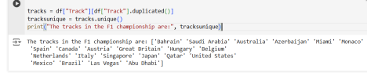

*● This code snippet just provides information about the tracks that are there in F1 season 2023.*

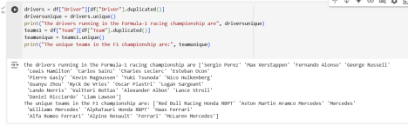

*● This code snippet just provides information about the drivers and the teams that are there in F1 season 2023.*

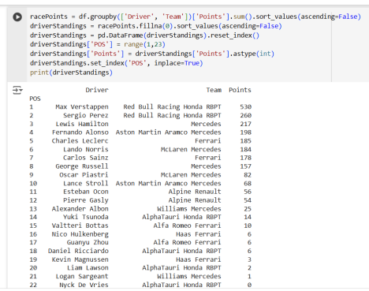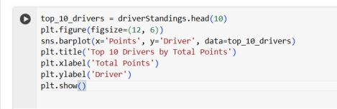

*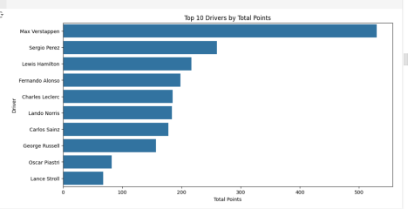****● Max Verstappen wins the Drivers’ Championship of the Formula-1 Racing Season 2023 earning 530 points in total with Sergio Perez***

***ending at the 2nd position with 260 points in total and Lewis Hamilton ending at the 3rd position with 217 points in total.***

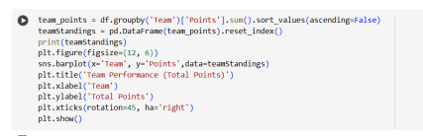

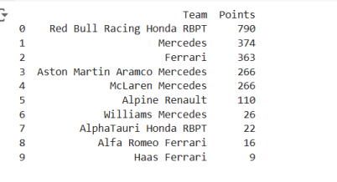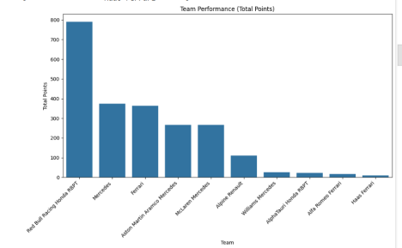***● Red Bull Racing Honda RBPT wins the Constructors’***

***Championship of the Formula-1 Season 2023 earning 790 points in total with Mercedes ending at the 2nd position with 374 points in total and Ferrari ending at the 3rd position with 363 points in total.***

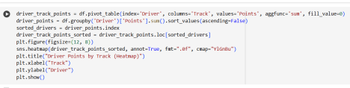***● This creates a heatmap of the Drivers’ points in each track.***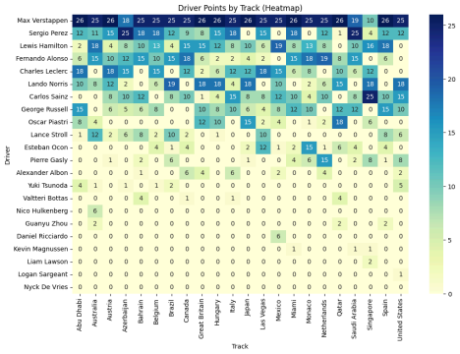

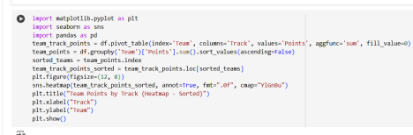***● This creates a heatmap of the Teams’ points in each track***





*******●* ***Max Verstappen*** *dominated with* ***9 fastest laps*** *this season, showcasing*

*his unmatched consistency.* ***Lewis Hamilton*** *followed with* ***4 fastest laps****, proving he's still a fierce competitor. Meanwhile, rookie* ***Oscar Piastri*** *impressed by matching* ***Sergio Perez****'s* ***2 fastest laps*** *despite*

*finishing 9th in the standings, hinting at his potential to be a rising star in the sport.*

**

*● In Formula 1,* ***NC*** *stands for* ***Not Classified****. It indicates that a driver has not met*

*the requirements to be of icially listed in the race results, even if they finished the race.*

*●* ***Esteban Ocon (6 NCs)*** *and* ***Pierre Gasly (1 NC)*** *from* ***Alpine Renault*** *suggest that the issues may lie more with driver performance:*

*● Likely causes include driver errors, strategic mistakes, or inconsistent race management.*

*●* ***Alexander Albon*** *and* ***Logan Sargeant*** *from* ***Williams Mercedes*** *have been* ***NC 4 times****, indicating team-related issues:*

*● Key factors could be mechanical failures, reliability issues, or pit stop errors.* ***Insights:***

*● Alpine drivers should focus on improving race discipline and mistake reduction. ● Williams needs to enhance car reliability and pit stop performance to avoid retirements.*

**

*●* ***DNF*** *stands for* ***Did Not Finish****, meaning a driver did not complete a race or qualifying session due to issues like technical failures, accidents, or other problems.*

*● A* ***DNF in Q1*** *for* ***Logan Sargeant*** *from* ***Williams Mercedes****, especially twice, points to* ***reliability problems*** *or* ***operational errors*** *during qualifying. It indicates that the team needs to improve in terms of car performance, reliability, and qualifying strategy to avoid starting from the back of the grid and to improve their chances of scoring points.*

*● A* ***DNF in Q3*** *for both drivers indicates that while McLaren's car has the* ***pace*** *to reach the final qualifying session,* ***technical or strategic issues*** *during Q3 prevented them from improving their positions.*

*● The team will need to work on* ***reliability****,* ***setup optimization****, and* ***race strategy*** *to ensure both drivers can capitalize on their* ***potential*** *during qualifying sessions and secure better grid positions for the race.*

**

**

**

*●* ***Esteban Ocon’s 7 DNFs*** *and* ***Pierre Gasly’s 3 DNFs*** *highlight significant reliability concerns for* ***Alpine Renault****. Both drivers have faced multiple mechanical issues or race-ending incidents, which have severely hampered their championship aspirations. With both drivers unable to finish races consistently, Alpine needs to improve car durability and strategic decisions to ensure better race outcomes and help secure more points.*

*● For* ***Williams****, both* ***Albon*** *(4 DNFs) and* ***Sargeant*** *(7 DNFs) have experienced* ***multiple retirements*** *this season, pointing to recurring* ***reliability issues*** *and* ***car performance gaps****. These* ***mechanical failures*** *or* ***strategic errors*** *have left the team with little opportunity to collect points. With both drivers frequently retiring early, Williams must address its* ***car reliability*** *and* ***strategic execution*** *to compete more ef ectively in the midfield and avoid further DNFs*

**

**

*● Not reaching Q3 typically means that the driver and team lack the ultimate qualifying pace to challenge for a* ***top 10 grid position****, making it more dif icult to*

*fight for higher points in the race. It highlights the need for improvement in car performance, strategy, or driver consistency to progress further in qualifying and improve race outcomes.*